- Find the efficiency of the ring where data rate of the ring is 4 mbps, no. of stations are 20, separated by 100 meter and bit delay in each station is 25 bits. Recalculate the problem for 16 mbps data rate of the link with 80 stations. Assume early token reinsertion with packet size of 1000 bits. (10)
- The Frame transition diagram shows an exchange of Ethernet frame between two computers A and B via 10BaseT hub. Each frame sent by computer A contains 1500 bytes of Ethernet payload data, while each frame sent by computer B contains 40 bytes of Ethernet payload data. Calculate the average utilization of the media during the exchange (10)
0.6 sec
A
B
- A TCP machine is sending windows 65,535 bytes over a 1-Gbps channel that has a 10 msec one way delay. What is the maximum throughput achievable? What is the line efficiency? (10)
- If size of a TCP segment is 1KB and header length value is 6, the sequence number = 3500. Given that URG flag = 1 and URG pointer = 45. Then what is the total size of data. How many of them are urgent, Give the sequence numbers of urgent data. (5)
- IP packets whose total length (data plus header) is 16Kb basting out of a router live for 15 seconds. The maximum line speed (in MBPS) of the router can operate at without cycling through the IP datagram identification number space is? (5)
- A building running CSMA – CD protocol is having a bandwidth of 512Mbps and distance of 2 kilometers then determine the minimum data size in order to detect a collision. Assume that the signal speed is 2, 00,000 km/s. (5)
- A 40 Mbps broadcast network that controls medium access using polling has 20 hosts and time required for polling the next host is 80 μsec. Whenever a node is polled, it is allowed to transmit 4000 bytes. Find the efficiency of the broadcast channel. (5)
- Calculate the effective throughput for transferring a 1000KB file assuming TCP using slow start congestion control technique. Given the round trip time 100 ms, and maximum segment size is 1460bytes. Assume there are no losses and both the bandwidth and the receiver window size is infinite. (5)
- An IPv4 datagram has arrived in which the offset value is 800, the value of HLEN is 8, and the value of the total length field is 500 and the M bit is 0. What are the numbers of the first byte, the last byte and the position of the datagram? (5)
- In TDM medium access control bus LAN, each station is assigned one time slot per cycle for transmission. Assume that the length of each time slot is time to transmit 100 bits plus end-to-end propagation delay. Let propagation speed is 2 * 108 m/sec. Length of LAN is 1Km with a bandwidth of 10 Mbps. Maximum number of stations that can be allowed in a LAN, so that the throughput of each station can be 2/3 Mbps (10)
- Consider the network with 6 Routers R1 to R6 with links and weights as shown below:
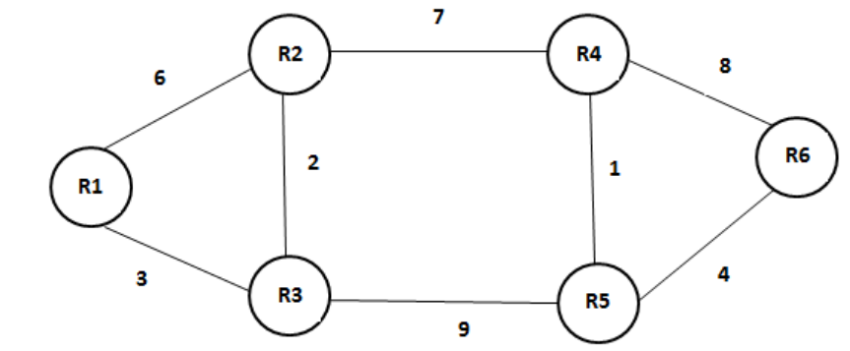
- After routing tables stabilize using distance vector routing. How many links in the network will never be used for carrying any data?
- Suppose, weight of all unused links in the previous question are changed to 2 and using DVR, all routing tables stabilizes. How many links will now remain unused? (20)
- The routing table of a router is shown as below:

Destination | Subnet mask | Interface
128.75.43.0 | 255.255.255.0 | Eth0
128.75.43.0 | 255.255.255.128 | Eth1
192.12.17.5 | 255.255.255.255 | Eth2
Default |  | Eth3

On which interface will the router forward packets addressed to destinations 128.75.43.16 and 192.12.17.10 respectively? (10)

- Consider three IP networks A, B and C. Host HA in networks ‘A’ sends message each containing 180 B of application data to a host HC in network HC. The TCP layer prefixes 20 Bytes header to the message. This passes through on intermediate network ‘B’. The maximum packet size, including 20B IP headers in each network is:
A. 500 Bytes,
B. 100 Bytes,
C.1000 Bytes.
The network A and B are connected through 512 Kbps link, while B and C are connected by a 256 Kbps link.
- Assuming that the packets are correctly delivered, how many Bytes including headers, are delivered to IP layer at destination for one application message in the best case? Consider only data packets.
- What is the rate at which application data is transferred to host H? Ignore errors, acknowledgements and other overheads?
- What is the extra overhead caused by fragmentation? (20)

